NFBCO Mile High Chapter
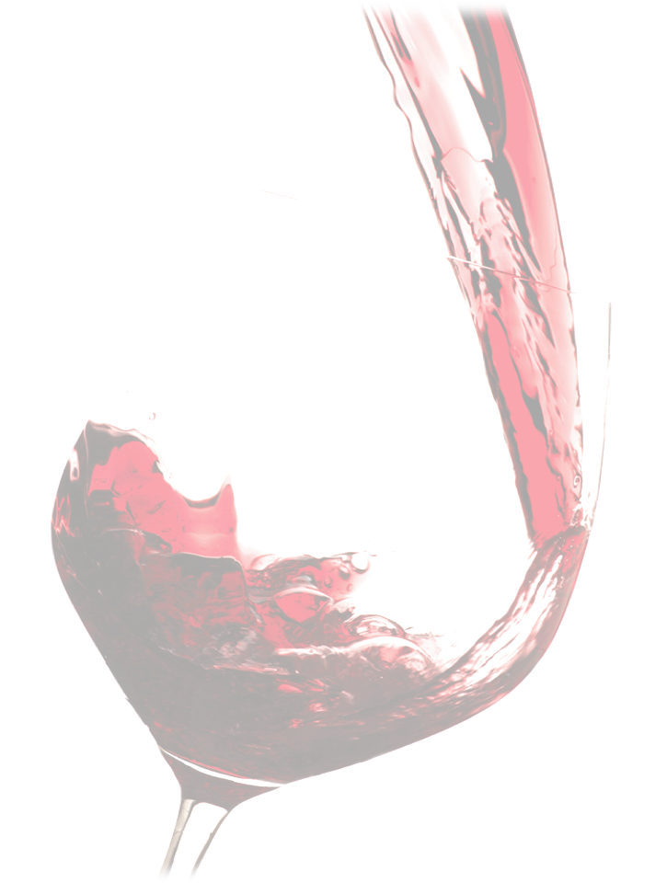
Join Us
Sunday, February 10, 2013
For an evening of
Dove Chocolate and D’Vine Wine Pairing

1660 Champa Street
Denver, CO 80202

2 PM to 5 PM
Enjoy tastings of five different wines paired with five different chocolates and more. Proceeds from this event benefit blind Children, Youth, and Adults.
Tickets $25
Purchase tickets at: https://www.paypal.com/cgi-bin/webscr?cmd=_s-xclick&hosted_button_id=ZYZEALXXK7DG6
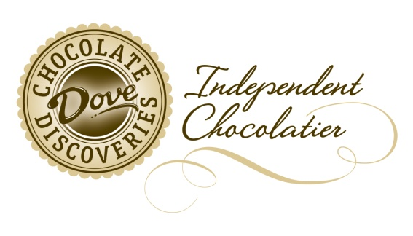
To get your chocolate on before the event
go to: http://www.mydcdsite.com/brendamosby.
To order, click the "Shop Online" area. 10 % of your order will go to the organization.

The purpose of the Mile High Chapter of the National Federation of the Blind of Colorado is to advance the general welfare of the blind through programs and services designed to improve the quality of life of the blind, parents of blind children; blind students, and seniors. Existing programs that promote the vocational, cultural, and social advancement of the blind include:

- Adult and Youth Programs
- Technology Training
- Education on blindness
- Support services for seniors impacted
by vision loss
- Free white canes

Your donation will help put a cane in the hands of children and adults throughout the country and the world.
Go to http://nfb.org/free-cane-program for more information.
If you know of anyone who could benefit from the services listed above, contact Jessica Beecham at
303-778-1130 extension 223 for more information. There are chapters established throughout the state and the country and new chapters being developed.

